**Assignment – 3**

**Practice Questions : 1**

**Q1) WAP to create basic calculator functions and call them**

**CODE :**

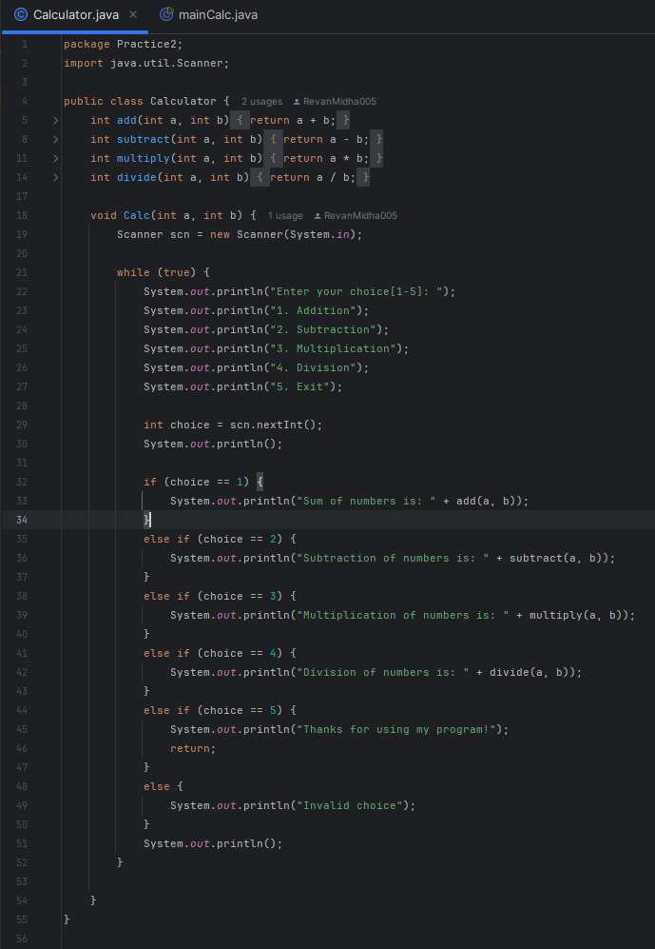

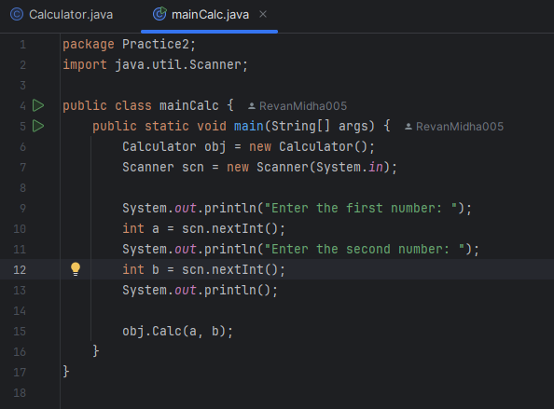

**OUTPUT :**

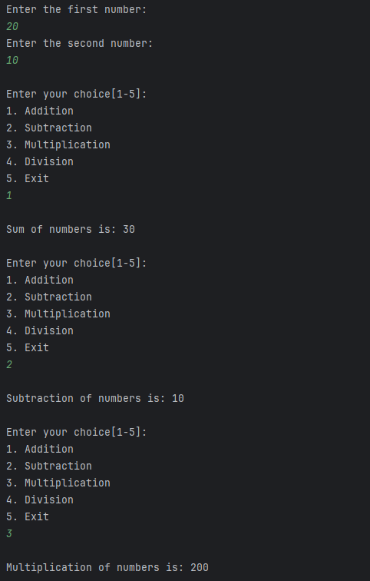

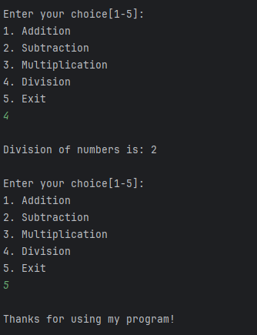

**HANDWRITTEN :**

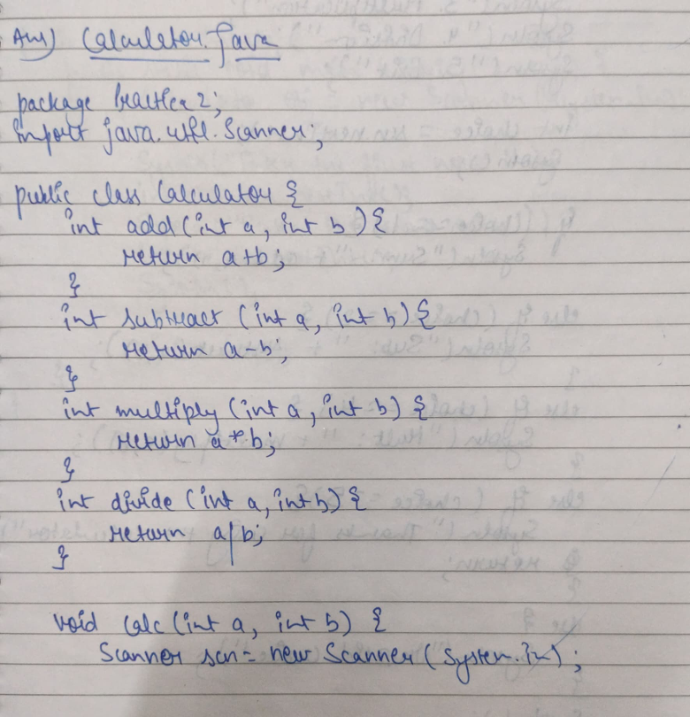

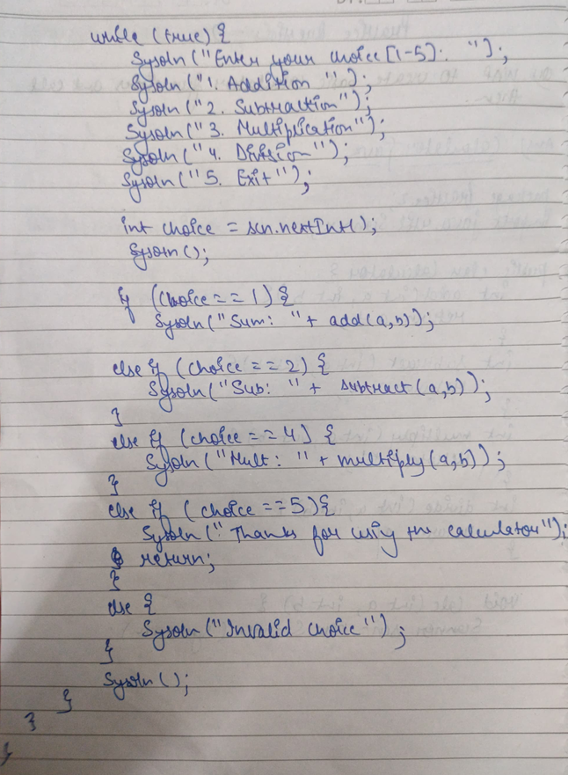

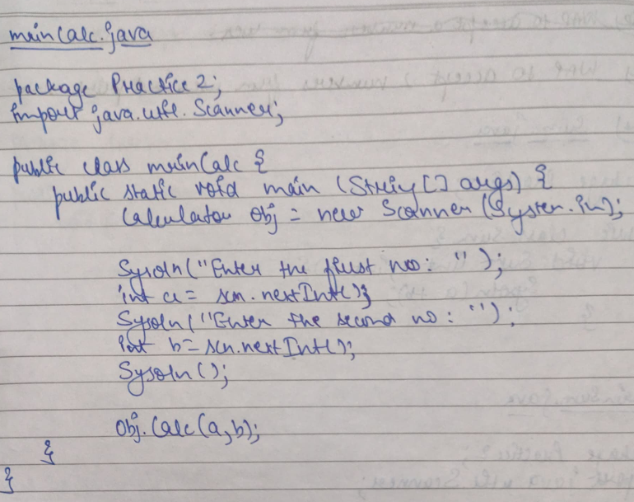

**Q2)  WAP to accept two numbers from user and print sum of them.**

**CODE :**

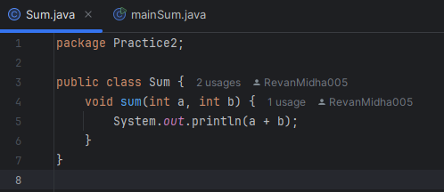

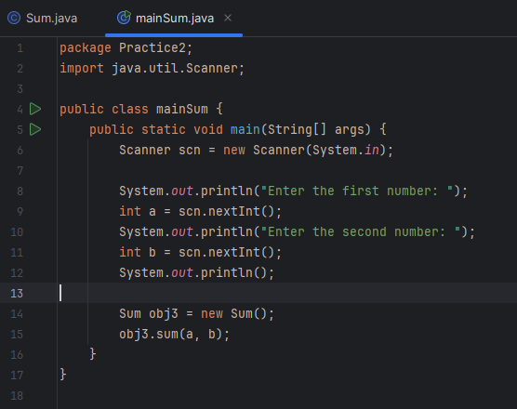

**OUTPUT :**

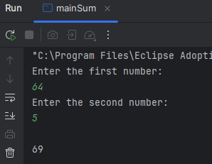

**HANDWRITTEN :**

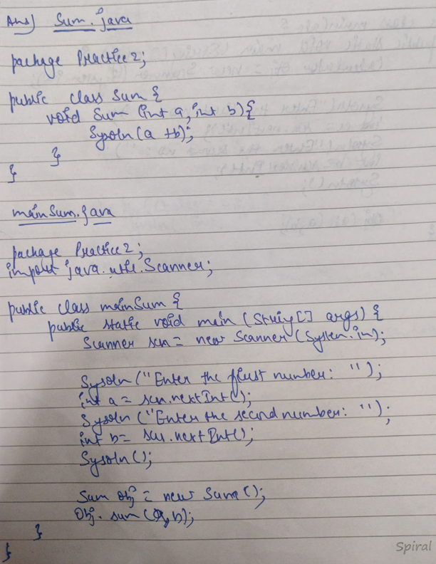

**Q3) WAP to accept  10 numbers from user and print sum and average of it.**

**CODE :**

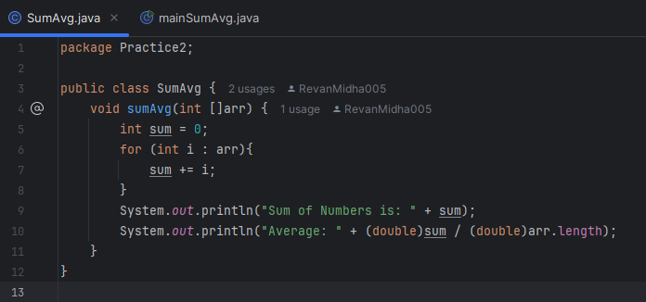

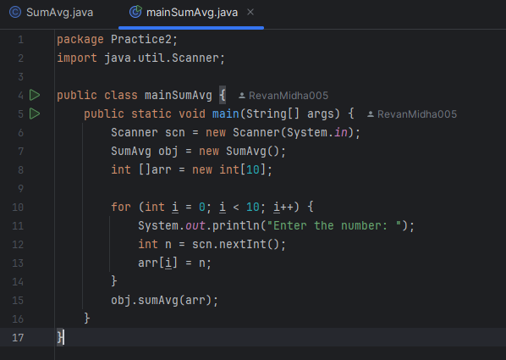

**OUTPUT :**

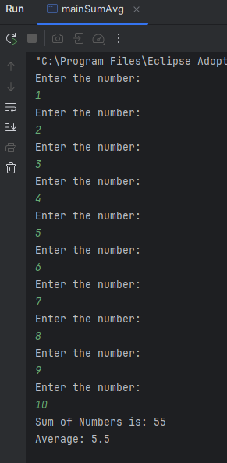

**HANDWRITTEN :**

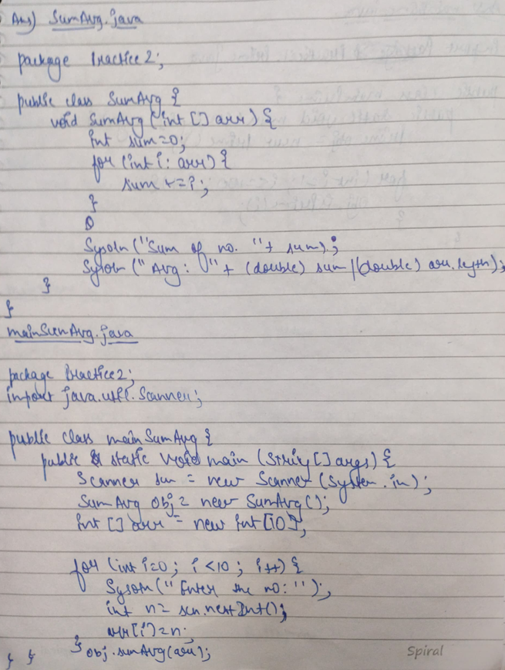

**Q4) WAP to print prime numbers between 1 and 100.**

**CODE :**

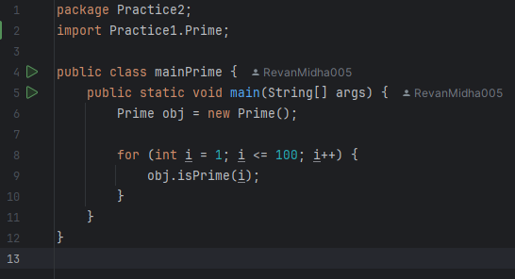

**OUTPUT:**

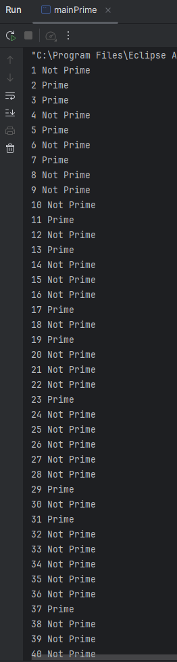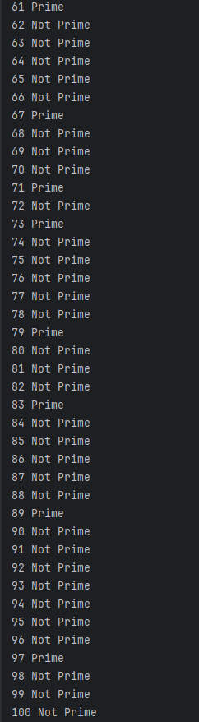

**HANDWRITTEN :**

